# Reibling et al. 2019 – Worlds of healthcare: A healthcare system typology of OECD Countries

## Abstract

In this paper, we present an extended typology of OECD healthcare systems. Our theoretical framework integrates the comparative-institutional perspective of existing classifications with current ideas from the international health policy research debate. We argue that combining these two perspectives provides a more comprehensive picture of modern healthcare systems and takes the past decade’s dynamic of reforms into account. Moreover, this approach makes the typology more beneficial in terms of understanding and explaining cross-national variation in population health and health inequalities. Empirically, we combine indicators on supply, public-private mix, and institutional access regulations from earlier typologies with information on primary care orientation and performance management in prevention and quality of care. The results from a series of cluster analyses indicate that at least five distinct types of healthcare systems can be identified. Moreover, we provide quantitative information on the consistency of cluster membership for individual countries via system types.

## Introduction

* Empirically, we develop an extended typology of OECD healthcare systems by combining indicators from the comparative-institutional perspective on supply, public-private mix, and institutional access regulations with measures on primary care orientation and performance in both prevention and quality of care. The results of our cluster analyses indicate that at least five distinct types of healthcare systems can be identified.
* Central aim of study: **We construct types of healthcare systems on the basis of a theory-guided preselection of relevant indicators**
* These types are constructed based on real-type indicators, namely OECD healthcare systems
  + However, they are not real-types or represent the extreme
  + They represent the **average country clustered** in its respective type
    - At the same time they can be clearly distinguished from each other
    - And be used to classify and compare existing healthcare systems (real cases)

## Evolution of healthcare system typologies

1. Field (1970) – Ownership and doctors’ autonomy

|  |  |  |
| --- | --- | --- |
| Type | Ownership | Doctors autonomy |
| Pluralist | Private provision | High |
| Health insurance | Social insurance actors | High |
| Health service | Mostly by State | High |
| Socialized health | Completely by State |  |

2. Schieber/OECD (1987) – Coverage, funding and owvership

|  |  |  |  |
| --- | --- | --- | --- |
| Type | Coverage | Funding | Ownership |
| National health service model | Universal | Tax financing | Public |
| Social insurance model | Universal | Social insurance financing | Public and Private |
| Private | Private insurance | Private financing | Private |

3a. Rothgang (2010) and Böhm et al. (2013) – Focus on health policy actors

* Rothgang combined the dimensions Governance, Financing and Provision with 3 different types of actors: Public, private, private non-profit and revealed 27 types
* Böhm et al. (2013) tested the existence in OECD countries and revealed 5 true systems
  + The National health service, the National health insurance, the Social health insurance, the Etatist social health insurance, and the Private health system

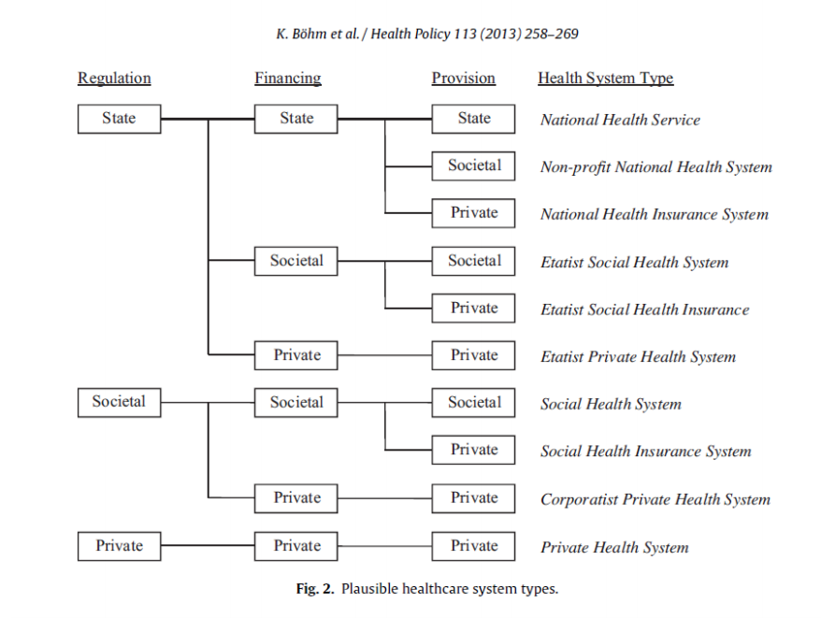

3c. Wendt et al. (2009) – Focus on institutional settings

* Focus on patients’ access to healthcare
* Healthcare system type with 1) high service supply and weak regulation, 2) medium to high supply and strong access regulation and 3) low supply and strong access regulation

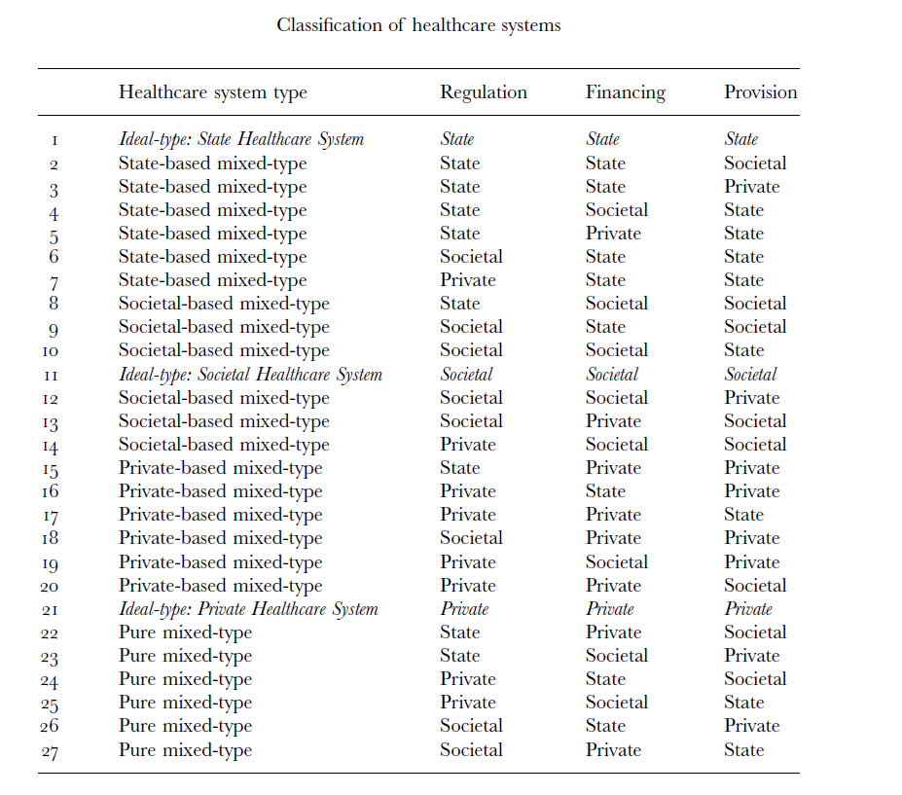

## Aim of the study

* To integrate both perspectives on healthcare systems to provide a more all-encompassing classification of healthcare systems
* The basis for such an integration is the definition of theoretical dimensions and empirical indicators

|  |  |  |
| --- | --- | --- |
| **Dimension Healthcare** | **Indicator Healthcare** | **Note** |
| Supply I | Current expenditure on healthcare per capita |  |
| Supply II | Number of general practitioners/1000 inhabitants | Measure of human resources supply |
| Public-private-Mix I | Share of public health expenditures |  |
| Public-private-Mix II | Share of out-of-pocket payments of the total health expenditure |  |
| Public-private-Mix III | Renumeration of payment for specialists  0: fee-for-service  1: salary | Fee-for-service payment of self-employed specialists vs. provision of specialist care through salaried employees |
| Institutional access regulation I | Requirement to register with a GP (0/1) +  Access of specialist care  0: Referral from GP  1: w/o referral but w/ additional co-payment  2: w/o any restriction | Social rights in the healthcare system = the regulations that define the conditions under which individuals have access to care  Possible values 0-3 |
| Institutional access regulation II | Whether systems generally have cost sharing for GP visits (0/1) |  |
| Institutional access regulation III | Whether individuals can choose the specific provider (0/1) |  |
| Primary care orientation I | Ratio of general practitioners to specialists | Ratio Positive -> country has more GP than Specialists and vice versa |
| Primary care orientation I | Share of health expenditure on outpatient care of the total health expenditure | How strong ambulatory care is in the respective country |
| Performance in prevention I | % of daily smokers in population aged 15+ |  |
| Performance in prevention II | % of alcohol consumption in liters in population aged 15+ |  |
| Performance in quality of care I | Quality sum index of six indicators | Number of hospital admissions per 100,000 (age-sex standardized rate, 15+years) for  (1) asthma and COPD  (2) congestive heart failure and hypertension  (3) diabetes  as well as 30-day mortality after hospital admission per one hundred hospital discharges (age-sex standardized rate, 45+years) for  (4) acute myocardial infarction  (5) hemorrhagic stroke  (6) ischemic stroke |

## Data

* 29 OECD countries
* Average value of the years 2011 to 2014 since not all countries provide data on each specific year

### Imputation:

* If data was missing: We used three different imputation methods. First, data were imputed from other sources, such as the Health in Transition reports. Second, data were imputed using interpolation of earlier values. Third, nearest neighbor imputation was used if the two other options were not available.

### HiTs

* Indicators and indices on access regulation, cost sharing choice restrictions and the renumeration of specialists are based on the coding information from countries’ most recent Health in Transition Report (HiT) provided by the European Observatory on Health systems and Policies
  + <http://www.euro.who.int/en/about-us/partners/observatory/publications/health-system-reviews-hits/full-list-of-country-hits>
* Although parallel healthcare systems with differing regulations are in place in some countries, the codes refer to the system for the majority of the population. The data refer to the year 2013, yet most HiTs were published before or after this year; thus, we checked the accuracy of the data with health policy experts for each country
  + To do this, we developed questionnaires in which country experts were able to check, correct, and comment on our data coding. Questionnaires were sent via e-mail between May and November 2016, and we received 47 back, with at least one and a maximum of four from each country
  + When differences between the original codes based on the HiTs’ and experts’ codes occurred, the authors discussed and determined the final codes by consulting additional experts and searching for additional reliable data sources

## Methods

### Cluster analysis

* Cluster analysis has become the standard method of classification for welfare state- and healthcare systems (Reibling et al. 2010; Wendt 2014; Minas et al. 2014)
* Great advantage of being able to systematically take into account the information on a larger set of indicators when assigning cluster membership
* However technical decisions have to be made and there are no widely accepted standards or statistical properties that can be used for determining the best solution (Fonseca 2013)

#### Decisions

1. Standardization method for variables

* Because variables have different scales, a standardization is suggested
* Milligan/Cooper (1987) argue that standardizing by range may lead to better results

2. Clustering method

* Hierarcical agglomerative clustering most popular **(Source?)**
  + Treating each observation as a single cluster and consecutively merges observations until they are all in one cluster
* Partitioning cluster
  + K-means clustering uses within cluster-variation as a method of forming homogenous clusters
  + Cases are divided into a predefined number of clusters, then cases are reassigned in iterative steps until all observations are as close as possible to the cluster mean

3. (dis-)similarity measure

* Determines the distance between cases
* For metric variables the most widely used dissimilarity measure is Euclidean distance
* Also commonly used in mixed-scale data **(Source?)**
* Only available mixed-scale type coefficient: Gower’s dissimilarity index **(Source?)**

4. linkage method

* Which method?

5. Number of clusters

* Usually based on stopping rules and inspecting the dendogramm
* Large increases in the agglomeration coefficient signal the fact that very different clusters have been combined which could indicate a good stopping point **(Source?)**

#### Criticism

* Findings depend on the type of decision made
  + E.g. findings will differ if the average distance (average linkage) vs. shortest (single linkage) is used
  + This led to a rather critical perspective towards cluster analysis (Fonseca 2013)
* However, the variation also just reflects the fact that there are different ways of looking at a specific dataset in terms of cluster groupings. Most studies present one or two cluster solutions with a specific set of standardization, clustering method, algorithm, and measure that follow mostly previous work (Reibling 2010; Wendt 2009; Minas et al. 2014) because “statistical properties of these methods are generally unknown” (Fonseca 2013: 406)

#### Solution

In this study, we instead propose conducting a larger number of cluster analyses and using the variability across the results as a measure of confidence about the membership of two observations in one cluster

* Step I: We thus conducted cluster analyses with

(1) both z- and range-standardized variables

(2) Gower and squared Euclidean distance as dissimilarity measures

(3) hierarchical, agglomerative cluster and k-means partitioning analysis

(4) average and Wards algorithms for hierarchical, agglomerative cluster analysis

(5) we selected the first- and the second-best result for each analysis as suggested by Calinski-Harabasz and Duda-Hart indices & stopping rule and the dendrogram

* Step II: Based on the 24 cluster results, we calculated how often each country is in the same cluster with every other country (measured as a percentage). Results from hierarchical cluster analyses (16) and k-means cluster analyses (8) each go equally into the final result. The resulting network matrix indicates cluster strength. We set benchmarks to account for different degrees of membership in a cluster:
  + full membership (≥66%) and
  + partial membership (≥50%

## Results

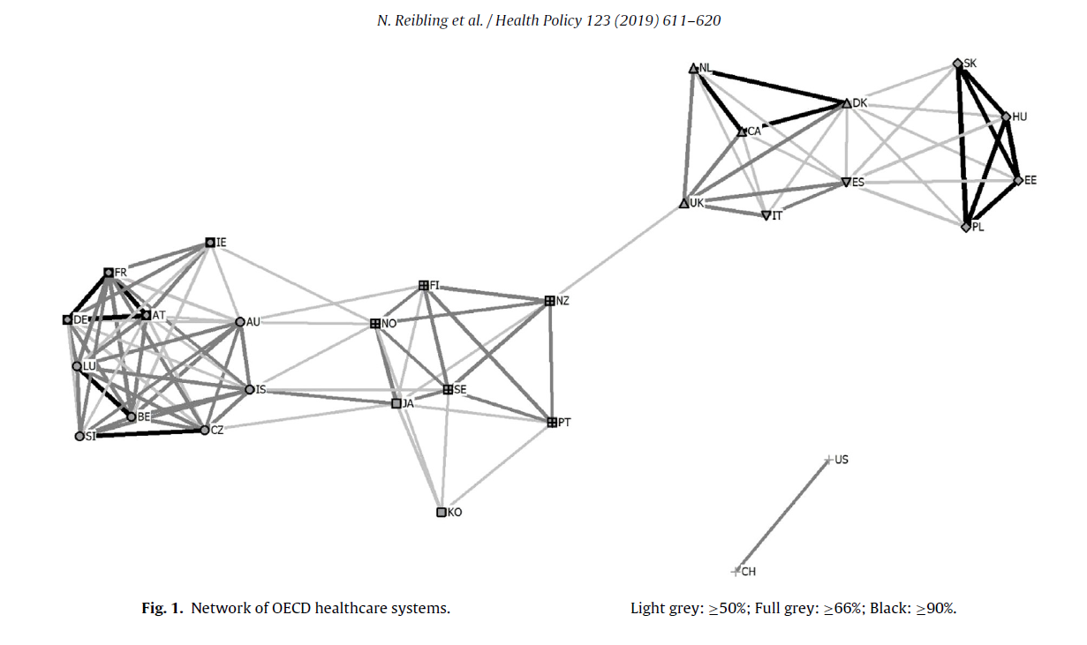

* Fig. 1 depicts the existing clusters that illustrates all link >= .5 and was generated using UCINET6/Netdraw (Borgatti 2002a; Borgatti 2002b)

